About Innovation Centre
Be it Satya Nadella, Rajeev Suri or many such global CEOs, MIT has a track record of nurturing global leaders for more than 60 years. This may be mainly attributed to multidisciplinary, multinational, pan India, multicultural environment in the campus enabling all-round development in the student. In addition, freedom for the students has enabled them to have self-discipline, openness to come up with new ideas, to take ownership of their decisions and actions.
Being innovative and creative, every student came up with some innovative ideas to solve some stressful issues of society. Also, the majority of the students had potential to be entrepreneurs. The Institute felt the need to nurture both these qualities of the students and Institute leadership with input from university, deliberated on this for some time to address implementation aspects. As an outcome of this, the Innovation Center to promote and facilitate Innovation was started in 2007. Further, to take innovative projects to society, Manipal University Technology Business Incubator (MUTBI) came into existence in 2009. MUTBI is for students, faculty members, alumni of MAHE and for the people of the region.
Manipal Academy of Higher Education, renowned for its commitment to academic excellence, not only prioritizes education but also recognizes the importance of fostering innovation and entrepreneurship. The Innovation Centre serves as a hub for innovative thinkers and budding entrepreneurs, providing a supportive environment to nurture their ideas and transform them into successful ventures.
The Innovation Center provides a variety of resources and conducts various events to promote ideation to startups. The newly opened Idea Café in the Marena Recreational Complex encourages interdisciplinary teams to meet, network and brainstorm complex problems. We have regular seminars and workshops for our aspiring innovators and entrepreneurs to learn new concepts, network and share their ideas and challenges. These evening programs make it convenient for students across all colleges to participate.
Teams formed during ideation are provided collaborative, co-working space at “Excelerate” in the Innovation Center. Removed from the hustle and bustle of hostel life, here students from different MAHE Institutions can develop and test their ideas and turn them into viable projects in this modern co- working facility.
At Makerspace we provide innovators with a wide range of tools and equipment to develop their proof- of-concepts and working prototypes. We also have several 3-D printers as part of our Center for Rapid Prototyping. Promising teams receive seed funding to defray the costs of developing prototypes.
In July 2018, the Innovation Center started the brand new, State-of-the-Art Apple Creative Studio. This is the home of the i0S Software development course offered to MIT and non-technology students as well. We offer training workshops for faculty and students across MAHE. Here students are encouraged to develop App with guidance from faculty trained at the Apple Training Center, Bengaluru, as well as regular interactions with experts from local i0S software companies.
When you are ready to start your own company, our Incubators (MUTBI and the Bioincubator) provide our budding entrepreneurs with all the resources and expertise needed to help them succeed.
The Innovation Centre also hosts a well-resourced Central Instrumentation Facility (CIF) to support multi-disciplinary research areas in emerging frontier fields by our students and faculty. CIF includes large instruments such as Scanning Electron Microscope, Energy Dispersive analysis (EDAX), Nuclear Magnetic Resonance (NM R), X- Ray Diffractometer, Ion Chromatography, NIR-VIS Spectrophotometer and Nano Fiber Electrospinning Unit. These instruments are useful for interdisciplinary research and innovation in Emerging areas of Material Science, Biotechnology, Printed photovoltaic, Plasmonic biosensors, and others.
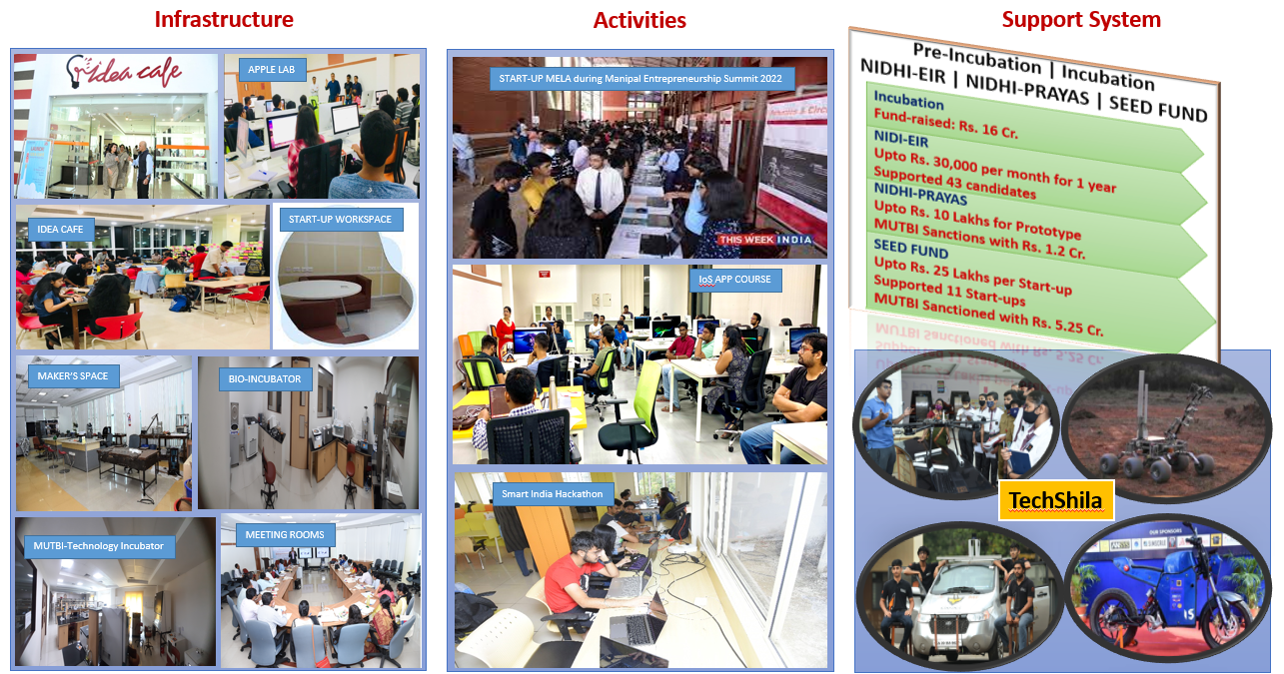
MIT support to Innovation and Incubation Activities of Students
MIT has always been in the forefront of Innovation. The state-of-the-art laboratories, support systems, mentorship from academia, industry and the vibrant ecosystem consisting of engineering, medical, dental, pharmacy, commerce and management have fostered inter-disciplinary ideas.
The culture of innovation is the core philosophy that defines MIT and has been vividly captured by the concept of 'Experiential Learning'. This is facilitated by providing open electives, opportunity to work in Major Student Projects, myriad of technical and non-technical clubs, hackathons, and final year projects. These initiatives are coupled with support from the Idea Cafe, Innovation Centre, Manipal Universal Technology and Business Incubator, and the Manipal - Government of Karnataka Bioincubator where MIT students have established several start-up companies. Apart from this, a few start-up ventures have been initiated on a voluntary basis by many students.
Start-up as Final Year: Now students at MIT can opt for the Start-up as their Final Year Project. This provision was enabled since 2020 and to date about 40 projects were identified and provided with pre-incubation status and accounted as final year project in the Iast 3 years. The outcomes of this initiative have resulted in formation of start-ups such as XeA Innovations Pvt. Ltd. Bangalore Assist aid Health Care Pvt Ltd, Bangalore, VAJRR, MUTBI Manipal, Pardus Camera Trap Solutions, SOCIIO Ichor- a social enterprise, Golden Bird Education (P) Ltd, Blue 0wI Solutions (P) Ltd, Hiranya Pathayee Technologies, IUVA Foods (P) Ltd, Nerd Nerdy, DoubtConnect, Bangalore, and many more to come.
MIT and Innovation Center encourage student innovations with several events.
We conduct a large number of Hackathons, Make-a-thons, and competitions to inspire students to participate in innovation. Our hackathons guide students through interdisciplinary team formation, ideation and early prototype development phases. Hackathons end with a short pitch to an interdisciplinary jury and awarding cash prizes and seed funding. During the past year we conducted the following events:
1 Ideation Competitions/Business Competition: We conduct numerous on- campus Ideation Competitions giving students opportunities to identify health and societal issues, convene interdisciplinary teams and develop creative solutions. We conducted in collaboration with Kasturba Medical College Manipal, MCODS Manipal, MCODS Mangaluru and MIT Manipal along with MAHE Department of Commerce.
2. Innovation Festival: It is our annual event to inculcate the spirit of innovation among MAHE students & faculty and create a common platform to showcase their innovation. Nearly fifty innovations were presented during this day-long gala at the Innovation Center.
3. Manipal Grand Challenge: The Innovation Center along with the Prasanna School of Public Health jointly conducted this competition for social entrepreneurs. While our students compete in national and international events, we encouraged them to use their creativity in developing innovative solutions to address local problems identified by the district administration.
4. Provenance: MAHE's Annual Business plan competition. It is the largest business plan competition in the region with prizes over 10 lakhs. Our primary goal is to encourage and foster a new generation of entrepreneurs. After a rigorous selection process, we identified three teams for further funding and pre-incubation services.
Some of the on-going MIT and MAHE student start-ups in Innovation Centre:
- Aion Health Solutions Private Limited: It is a healthcare technology company that aims to develop wireless Health Monitoring Device.

- Dent'flix: It is creating high quality dental content using animation and VR technique. In long term they are creating advance online dental platforms for all dental student and teachers.

- Red Mountain Healthcare: It is a health-care device development startup with the goal of designing, patenting, and marketing specialty medical and dental equipment. A dental aerosol evacuator is one of the products to prevent cross contamination between dentists and patients.

- Cupidity: Music is one of the most powerful things experienced by humankind. At Cupidity connect people based on their music preferences.

- Impact: Working in finance domain which revolves around investing, hedge fund, private cooperative banking, and try to revolutionise the banking industry even further.

- Formi: It is to digitalize the event industry and harness the power of data. Formi empowers event organizers to make informed decisions and optimize their operations. With their comprehensive suite of services, including seamless ticketing, marketing support, and advanced Point of Sale/Payment data analytics, we enable organizers to unlock valuable insights and drive event success.

- EVkal: It is working on observing the climate change and the increasing requirement for EV. They have come up with an idea of using salt water to produce electricity for the working which would solve the problem of long charging hours for EV’s.

- Ekspify Private Limited: A curated, campus focused, engineering experience, built specifically to help students understand and learn the different domains & courses out there! Live the campus life before getting into engineering. Ekspify Pvt Ltd is excelling at preparing students for the world, one step at a time, taking a unique approach to reform career counselling.

- GoldenBird Education: Golden Bird Education aims to pioneer innovation in and transform the educational sphere of India. We are a multifaceted organization - our operations range from providing individual online courses to collaborating with schools and universities to employ our course modules to a larger branch of students. They provide project-based software development courses designed to challenge all levels of experience. At highly affordable rates, our courses boast licensed software, certified professors and different languages to make sure no one is left behind.

- T2RS Private Limited: A electronics-based startup working on industry, consumer and community-based products. Making innovative IOT products to target different niche in industrial as well as consumer markets.

- Gaurav Agro Tech: Agriculture related tech like sprayer pump and research seeds.

- UseX: They wish to provide Indian consumers with the right service of customer experience and help businesses provide exactly that.

- Grito: Healthy, delicious meal prep delivered to your door. Tailored to help you achieve your specific health and fitness goals, with weekly progress check.

- Fetch: Platform with listings of restaurants, showrooms and local stores backed with intra-city delivery services provided at super-fast speed.

- Accelth: Accelth is an innovative start-up company that is dedicated to improving access to healthcare and cutting-edge technologies for people around the world.

- Swarm Robotics: Swarm Robotics is a student project that works by implementing AI and machine learning with swarm hive mind on ground and aerial bots.

- 225: It is a community-based streetwear fashion brand.

- Tranzit: Compliance as a Services for Visa Automation.

- Edu Hunt: Connecting students with coaching institutes. Helps find the right institute that caters to the student's needs. We help you find the best institute which caters to your needs.

- D DeckCard: It is dealing machine for the game of bridge which can manage the cards based on instructions giving by an authorized person.

- Jugaadus: Building modular, pocket friendly and energy efficient accessories to improve safety of vehicles.

- DoubtConnect: DoubtConnect is an online Ed-Tech doubt solving and concept learning platform. We connect students with tutors using real-time technology to have their doubts solved on a 1v1 video call.

- GoPerch: Perch Automated and organized parking system, with GoPerch there is no need to go around in circles for a parking spot or stand in long queues to play a game at an arcade center, or wait for a meal at your favourite restaurant. We are building an app that allows you to reserve wherever you go.

- Engagin: Engagin is a one-platform solution that transforms social experiences and brings the world closer through sports. They aim to provide users with an ultimate sports experience by facilitating the booking of sports facilities and venues through our platform!

- Ripple Technologies: Ripple Technologies intend to reduce the time of charging an electric vehicle by 70 percent. Currently no Type-3 DC charger is commercially available in India. Their proposal is for a new EV charging solution that aims to make the process more convenient and efficient for end-users.

- Mannkare: A pure fashion Marketplace for Independent Designers, Artists, Freelancers and upcoming Brands.

- Allmity (by Invallv): The OneStop solution to all your college needs. Allmity is an initiative started by MIT Manipal undergraduates to provide students with an enhanced college experience.

- Peryton technologies: Indigenous Drone manufacturing and servicing company. They are focusing on developing aerial system for various purposes. Currently working on Light Show Drone System.

- Instrumus: It is an online platform that aims to enhance scientific development by providing infrastructure sharing and collaboration opportunities.

- Delta Node: It is a marketplace-oriented platform exclusively built for the student community, enabling collaborative networking and development across various fields and interests in a particular institution or affiliation of universities. The goal is to accelerate startups, research projects, creative content and many more ideations at any stage.

- Fundinc: Introducing Fundinc, the revolutionary new investment platform that gives you access to the exciting world of private startup equity. Our platform makes it simple and easy for you to invest in a diversified portfolio of promising startups.

- Bixel Studios: Bixel Studios is a company dedicated in production of films, wedding stories, Music videos & provides editing services with various other services of digital marketing.

- Kraftr: This team is participated Hult Prize national level competition and made shoe out of deadstock and leftover. They are manufacturing of Eco-friendly shoes by local workforce and gifting them to children.

- One: With One, they are digitizing their textbooks and transforming them into 100's of Games, Animated stories, Virtual experiments, and AI-backed tests. Through this, we believe in pushing the probability closer to One.

- ERS Eventers: It is a business startup related to events and parties on campus and off campus.

- UpEase: A SaaS + Marketing solution aiming at developing a comprehensive learning system for higher education institutes. Utilising these learning systems, we work on building the academic perception of these institutes, driving admissions, ranking and other metrics.

- Holobox: It is focuses on interactive learning through hologram technology, and they believe that their innovative approach to education has the potential to revolutionize the industry.

- Bambus Energia: The idea of the project is to generate biomass energy with the help of bamboo and facilitate electricity generation. With remaining elements, they can produce fertilizers.

- Colour 3D Printing: Aim to build a fully coloured 3D Printer.

- Vennbrd: Vennbrd enables people to get anything from the internet or their phone and personalize their personal space.

- Eleganza Creations: We bring to you ecofriendly and aesthetic decorations for various celebratory events.

- Bugbase: They have established "bugbase" a bounty hunting platform. The success of this startup has been featured in many media outlets. The student team is extensively working on security solutions.

- Sthani: They elevate to-be-great brands with significant consumer love to remarkable heights by fostering their growth on their next-generation marketplace and expanding their presence globally.

- Navmarg Research and Innovation Pvt. Ltd: It is a research-based start-up working on transforming water challenges with advanced technology, addressing contamination, and pioneering innovations for societal and environmental well-being. It primarily works in the domain of water treatment and filtration, water monitoring and analysis, and the applications of embedded systems, applied chemistry and geosciences.

- VSARO: VSARO has undertaken the task of designing a UAV for disaster management purposes.

- Skyrobee Aerolabs: They specialize in the manufacturing of drones for military and commercial applications.
- Thapy: A Mental Therapy Marketplace utilized to connect therapists with users, has garnered attention for its innovative approach to mental health support.

- SaiphiaDUS Private Limited: Specializes in manufacturing, designing, and trading drones, robots, and machinery for defense, security, industrial applications, and mineral processing plants. They also provide industry-specific drone toolkits, artificial intelligence solutions, and support services globally. Additionally, they engage in designing, manufacturing, and providing technical assistance for cement plants and production systems.

- SmartContents: SmartContents provides solutions to daily grocery problems through the application of A.I. and real-time data production, aiding users in food preparation precisely when needed.

- SafeStone: SafeStone is a Social Safety Network platform that allows users to build their personal safety network by connecting with their friends, family, colleagues, batchmates and other communities. During an emergency, a user can send their live location and alert the nearest members of their network with the click of a button for a quick response.

- Rozzkaam: It empowers daily wage labor through innovative mobile solutions. These solutions have garnered attention for their potential to transform the lives of workers in various industries.

- Rezolvr Labs: They are focused on developing customizable virtual and augmented reality-based training modules.

- Rial: It is a service-based company that specializes in building and managing merchandise for influencers.

- Project DronAid: It aims to utilize drones for the delivery of medical aid.

- DotFood: It is a platform that unites students in MIT Manipal with the various food courts, food messes, food joints, juice lounges and restaurants within the campus. Aimed at reducing your wait to place an order, the DotFood app provides you an easy-to-use interface to select from multiple restaurants and place your order within minutes.

- Flying Electronics: It is a Made in India Drone Manufacturing and Service Company catering to various sectors such as film-making, agriculture, survey, consumers, etc.

- Automated Aeroponics: A proposal to use soil-less farming methods for large scale farming explores the utilization of soil-less farming techniques for large-scale agricultural operations.

- Thiranya Pathaye Technologies Private Limited: They have the vision of harnessing the power of artificial intelligence to streamline and innovate within the digital automation sector.

- Mulyo Clothing Private Limited: Mulyo merges Indian handicrafts with a Japanese urban flair, offering sustainable kidswear that champions comfort and style while promoting environmental education. Recognized as a top sustainable startup and awarded 'Brand of the Year 2024' by Business Connect Magazine.
- Expify: A provider of experiential counseling services, known for their innovative approach to therapy.

- Bamboozle: The company specializes in making apparel out of sustainable textiles like bamboo and Birla Excel.

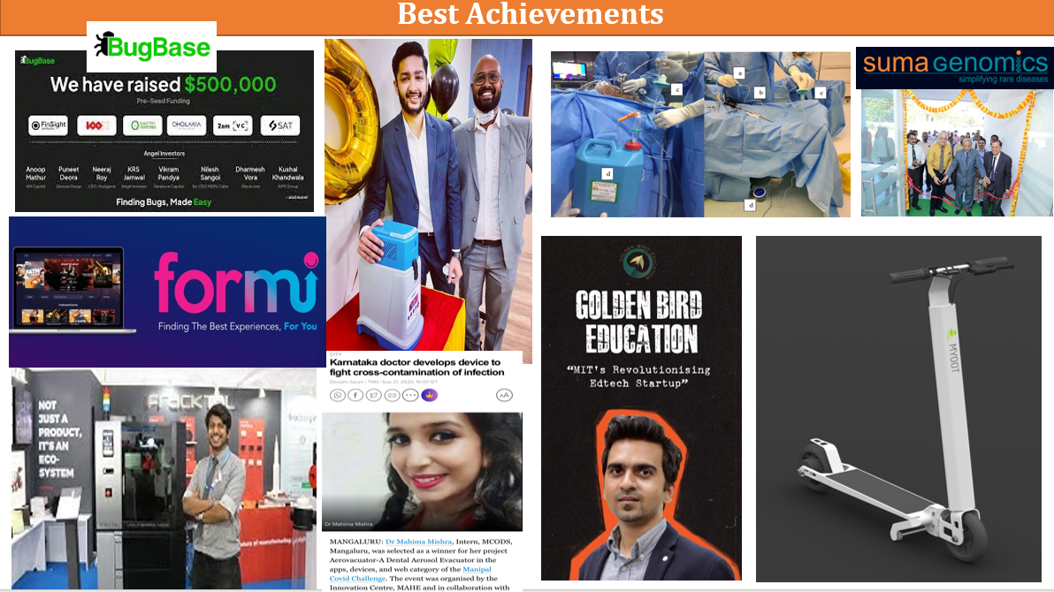
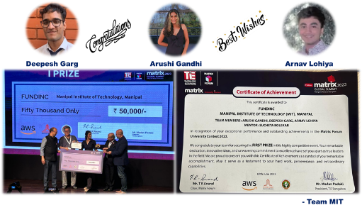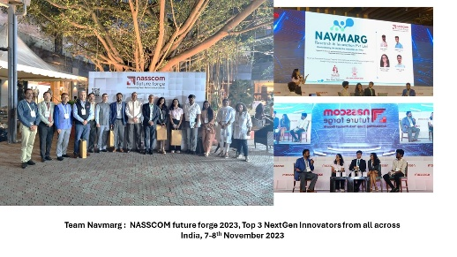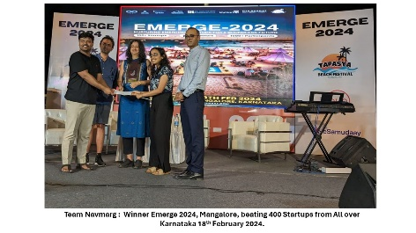
Innovation and Incubation Activities conducted by MIT.
- Confederation on Indian Industry (CII) Conclave Hackathon
MIT, Manipal and Innovation Centre, MAHE in association with CII Mangalore conducted Academia-Industry conclave 1.0 on 10th September 2022. As a part of the conclave, a hackathon was conducted on 9th September 2022 in which around 23 teams participated from various colleges. Out of 23 teams top 3 winners along with 5 consolation prize winners were shortlisted.
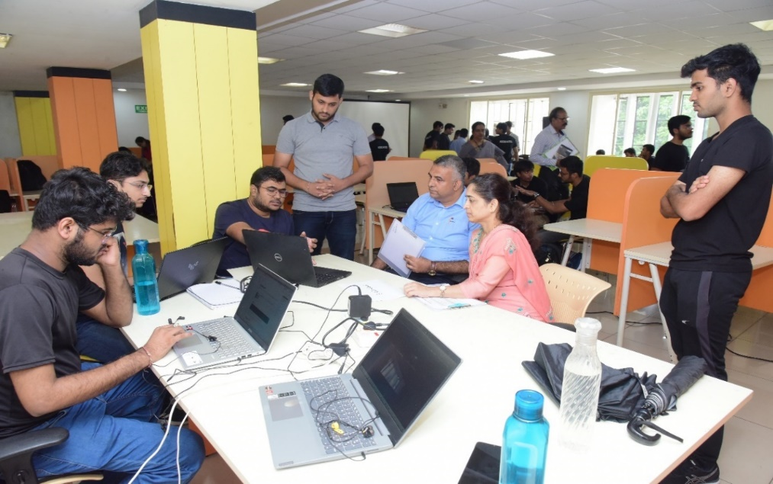
- Interactive Session with Mr Dipan Sahu- ATAMANIRBHAR BHARAT:
Provisions of start-ups for students in India. Hultz Prize MAHE with the support of Innovation Centre MAHE conducted its first event for the term, an interactive seminar with Mr Dipan Sahu on the topic, “Atmanirbhar Bharat and how can students contribute to it: Provisions of start-ups for students in India”. Various clubs like Manipal GoK Bio-incubator, ESOM and MCODS SRF partnered up to attend the event. The media body, MTTN covered the event.
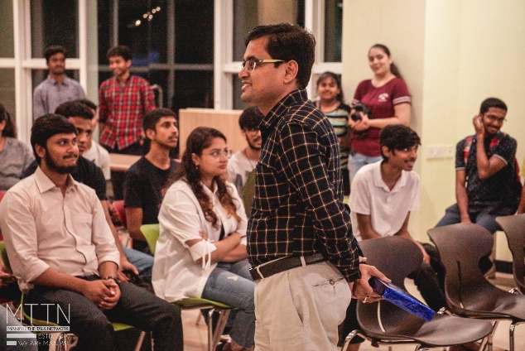
- Manipal Entrepreneurship Summit (MES), 2023:
MES, 2023, the sixth edition of the annual event was organized from 17th to 25th February 2023. This event is an annual flagship event of Manipal Academy of Higher Education (MAHE) to promote a culture of innovation and entrepreneurship among students through online and offline sessions involving panel discussions, keynote talks, startup pitches, and startup fairs.
The event is an initiative of the Entrepreneurship Cell (E-Cell) of Manipal Institute of Technology, Manipal, a student body managed and run by students to promote entrepreneurship across the Manipal Academy of Higher Education (MAHE). With a student population of 30000+ and a range of disciplines covering 300+ programs, MAHE offers a rich ambience for the spurt of innovation and entrepreneurial spirit among the youth.
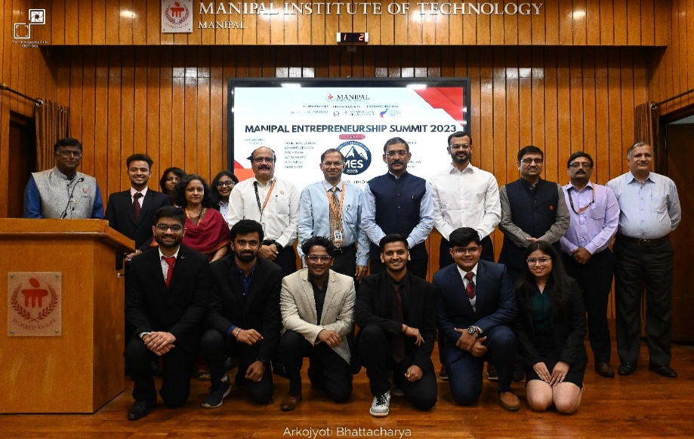
- Smart India Hackathon (Hardware Edition) Grand Finale - 2023 Hosted at MIT, MAHE, Manipal
In a significant achievement, Manipal Institute of Technology (MIT), Manipal, was chosen as the Nodal Centre for hosting the prestigious Smart India Hackathon (SIH) - 2023 Senior Hardware Edition in self-finance mode by the All India Council for Technical Education (AICTE), New Delhi. The national-level hackathon is an initiative of Ministry of Education’s Innovation Cell and took place from December 19th to 23rd December 2023.
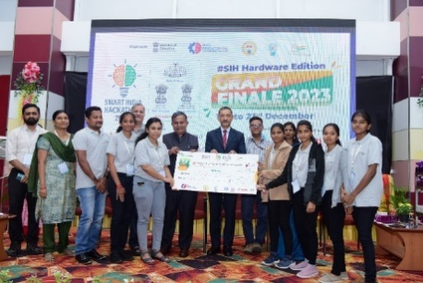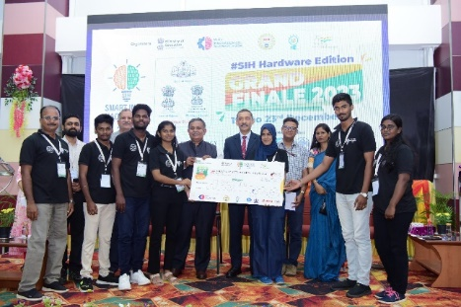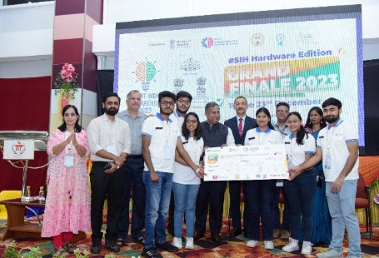
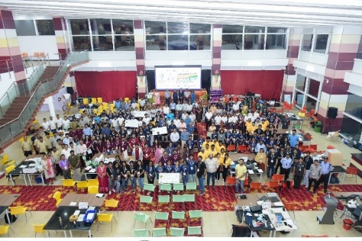

- Manipal Entrepreneurship Summit 2024
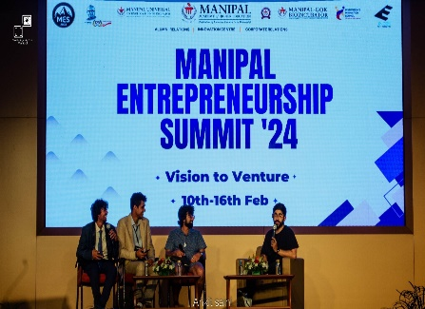
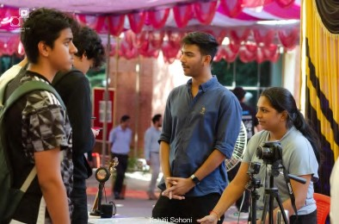
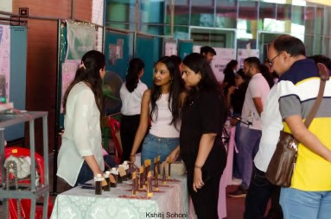
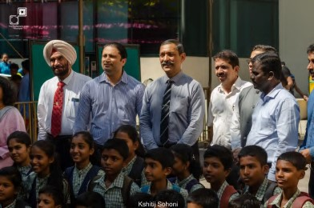
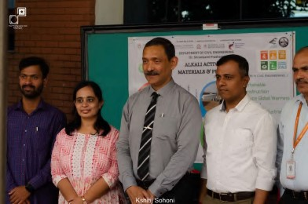
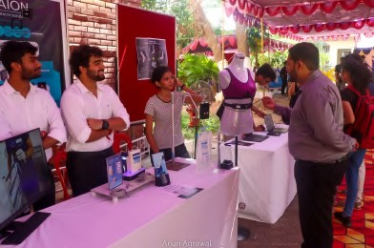
We at E-Cell, MIT Manipal, have stood for promoting entrepreneurship and innovation amongst the masses at the MAHE level. We have mapped Manipal’s startup ecosystem through exciting initiatives on the Indian Map. Manipal Entrepreneurship Summit’24 is one such initiative held from the 10th to the 16th of February, showcasing the journey and highlighting key entrepreneurship-led pointers of nearly 29 Founders, Creators, and Venture capitalists.
- Innovation Centre had the privilege of hosting Mr. Vinod Eshwaran, the esteemed Managing Director and CEO of Jio Payment Banks
On 26th November 2023, our institution had the privilege of hosting Mr. Vinod Eshwaran, the esteemed Managing Director and CEO of Jio Payment Banks, as the chief guest. The event aimed to provide students with valuable insights into the life and experiences of a successful innovator and start-up founder. Approximately 20 start-up stalls were curated and showcased.
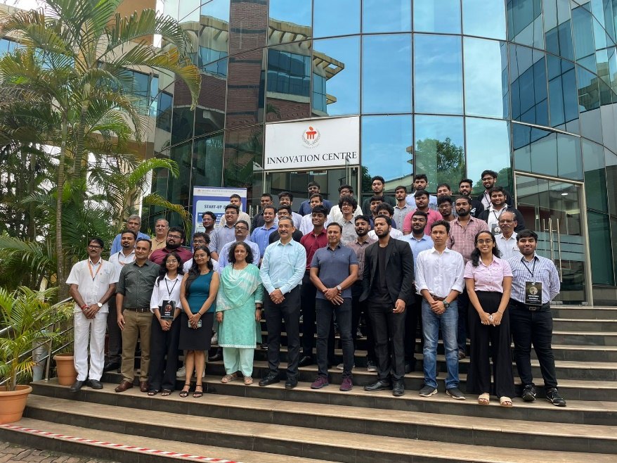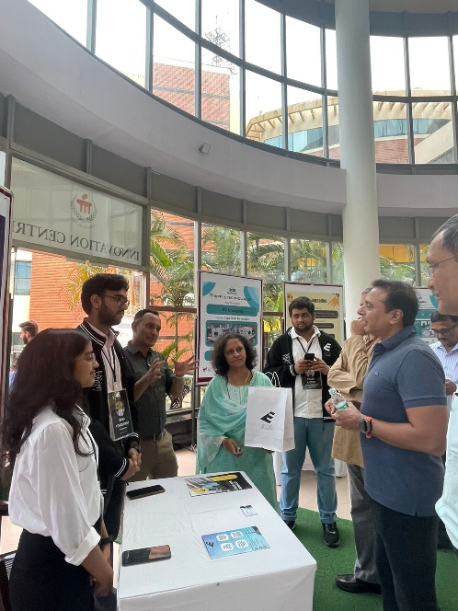
- Innovation Centre had the privilege of hosting an esteemed alumnus of MIT, Rajeev Chandrasekhar, Minister of State for Skill Development and Entrepreneurship and the Minister of State for Electronics and Information Technology in the Government of India
In honor of National Innovation Day on October 17, 2023, the Manipal Institution of Technology (MIT) hosted an event showcasing start-up stalls, reflecting its commitment to fostering innovation and entrepreneurship. A total of 20 start-up stalls were prominently displayed, featuring the creative and innovative projects of MIT's talented students. An esteemed alumnus of MIT, Rajeev Chandrasekhar, who currently serves as the Minister of State for Skill Development and Entrepreneurship and the Minister of State for Electronics and Information Technology in the Government of India, graced the event with his presence. Mr. Chandrasekhar took a keen interest in the showcased start-up stalls and engaged with the students, offering words of encouragement and motivation.
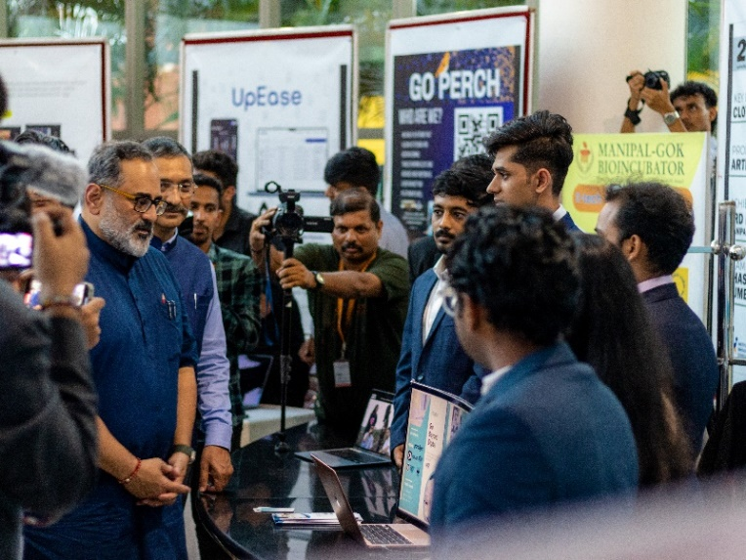
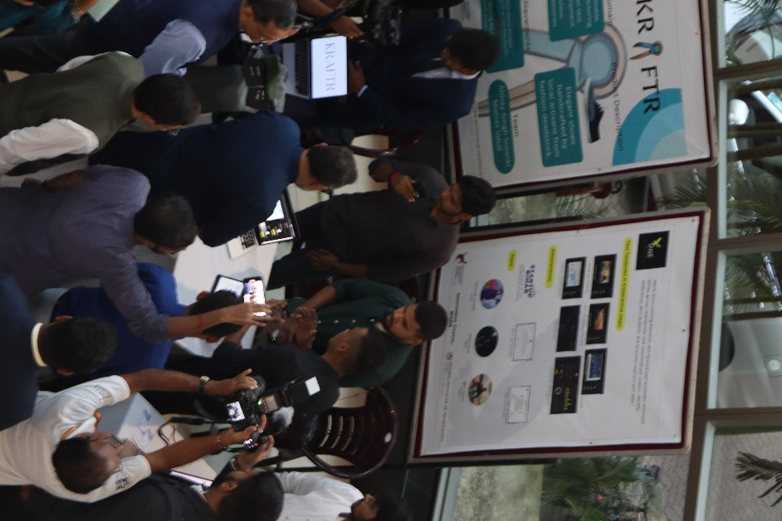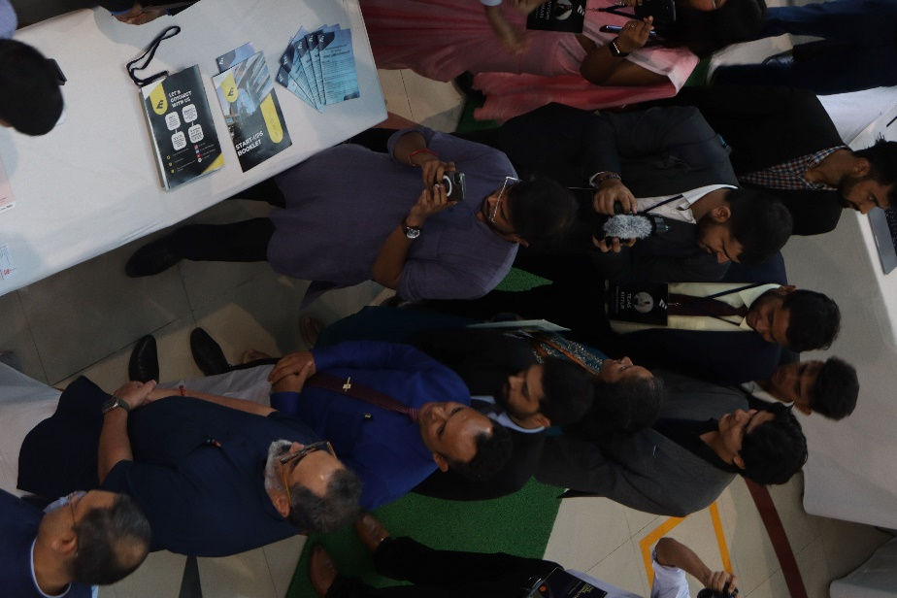
- Innovation Centre had the privilege of hosting Prof. T G Sitharam, Chairman of AICTE
On November 25, 2023, Prof. T G Sitharam, Chairman of AICTE, visited the Innovation Centre at MAHE, marking a significant event that underscored the institution's dedication to promoting innovation and entrepreneurship. The visit featured an impressive showcase of 20+ start-up stalls, each highlighting the inventive and entrepreneurial spirit of students. These stalls displayed a diverse array of creative projects, demonstrating the students' capability and commitment to technological advancement and problem-solving. Prof. Sitharam's visit not only celebrated these achievements but also reinforced AICTE's support for such initiatives, aiming to inspire and nurture the next generation of innovators and entrepreneurs. The event was a testament to MAHE's ongoing efforts to create an ecosystem that fosters creativity, collaboration, and cutting-edge innovation.
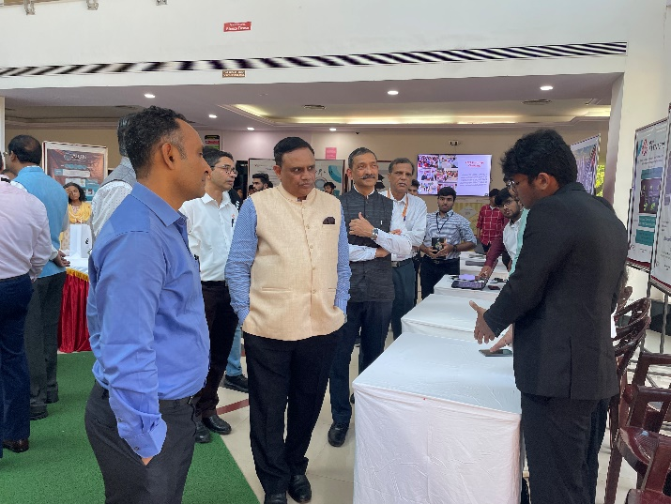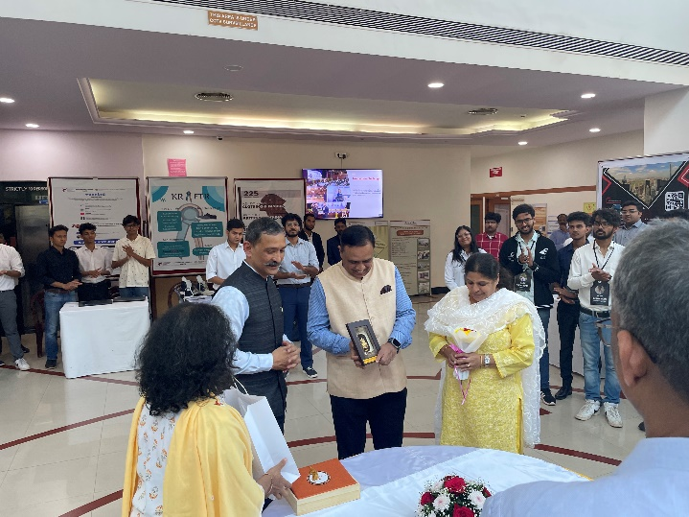
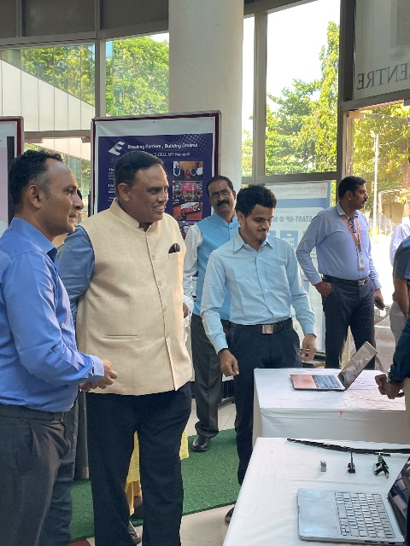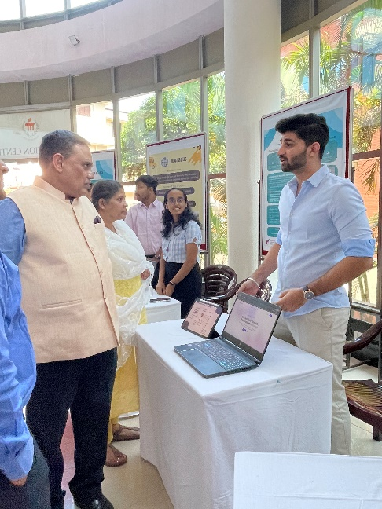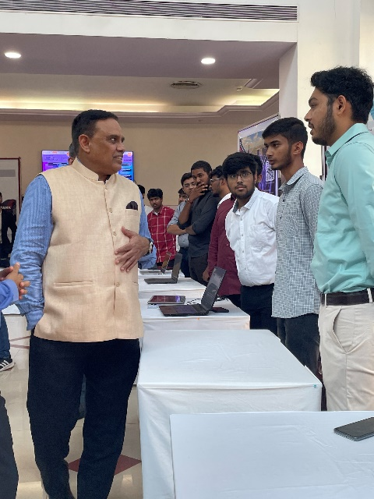

- Innovation Centre had the privilege of hosting esteemed alumnus Mr. Harish Shah, Founder and Managing Director of Signet Capital Pvt Ltd, and Director of the Harish and Bina Shah Foundation
On April 6, 2024, the Innovation Centre at Manipal Academy of Higher Education (MAHE) was graced by the presence of distinguished alumni Mr. Harish Shah, Founder and Managing Director of Signet Capital Pvt Ltd, and Director of the Harish and Bina Shah Foundation, accompanied by his wife, Mrs. Bina Shah, Co-founder of Signet Capital Pvt Ltd. Their visit underscored their commitment to fostering innovation and entrepreneurship within the institution. The event featured a showcase of 20+ start-up stalls, highlighting the creative and innovative projects of the talented students from the Manipal Institute of Technology (MIT). The presence of Mr. and Mrs. Shah provided an inspiring and encouraging atmosphere, reinforcing the importance of entrepreneurial initiatives and the vibrant start-up culture at MIT. The event demonstrated MAHE's dedication to nurturing the entrepreneurial spirit among its students, providing them with a platform to display their ingenuity and drive for innovation.
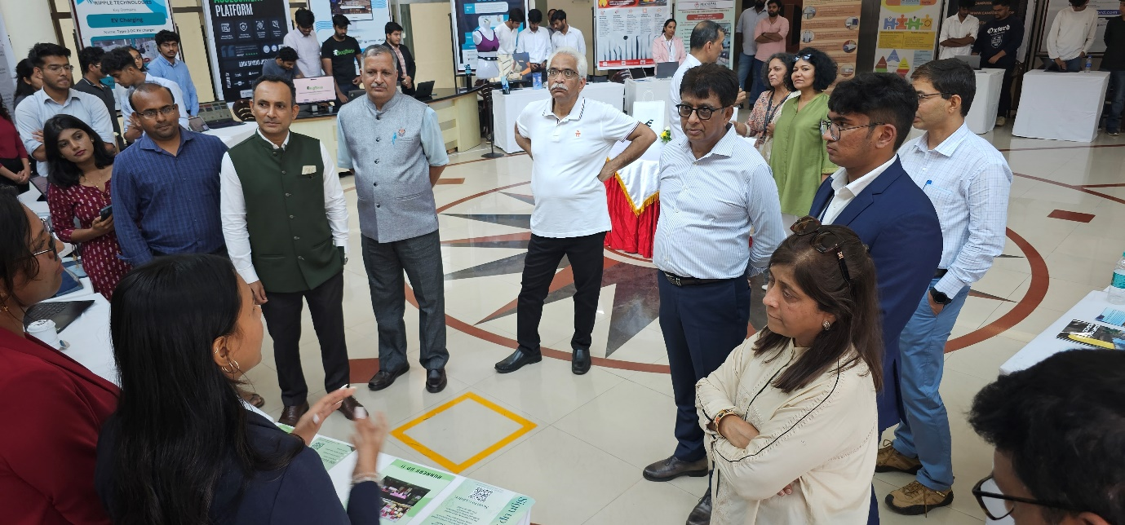
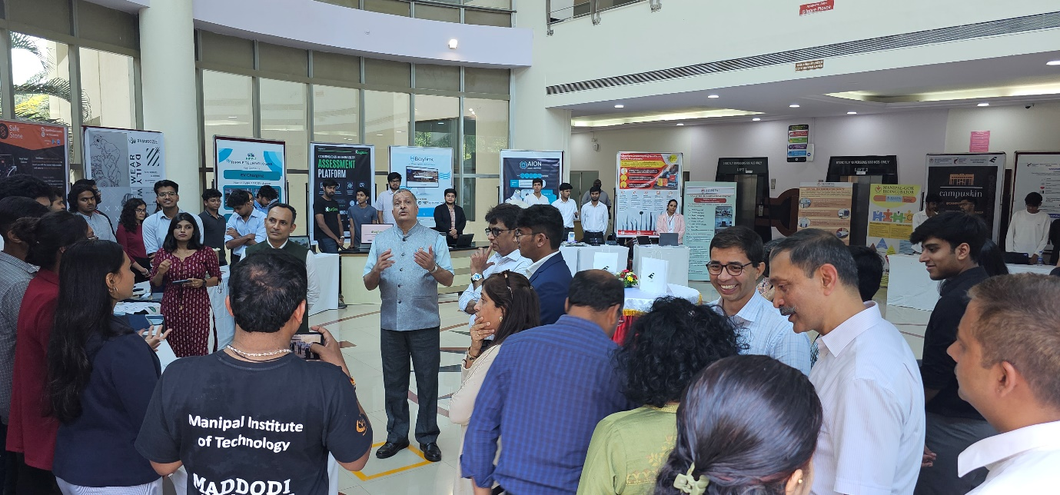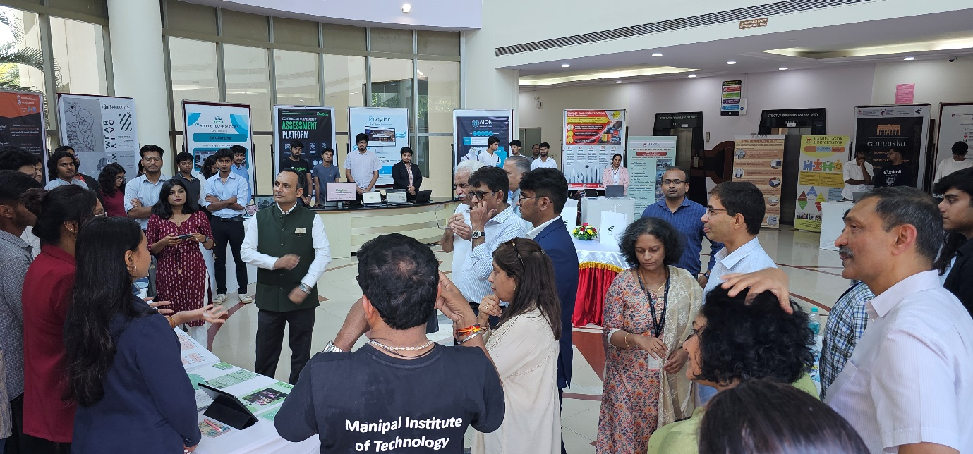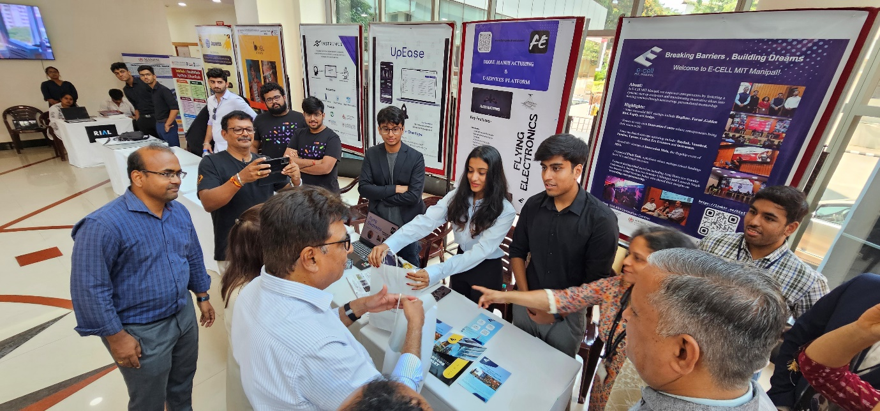

- MAHE organized National Conference on Youth in Social Change
The 3rd edition of the National Conference on Youth in Social Change was organized by Manipal Academy of Higher Education on 17th September 2022 at Manipal on the occasion of 87th Birthday of Dr Ramdas M Pai, Honorable Chancellor of MAHE. The aim of the conference was to encourage the concept of giving among the youth and to sensitize them towards bringing a social change and taking a step towards social entrepreneurship. Dr Ranjan R Pai, President, MAHE Trust, Chairman, Manipal Education and Medical Group launched the event through a cultural element of Tulunaadu, wherein the pingara flowers signify growth and prosperity.

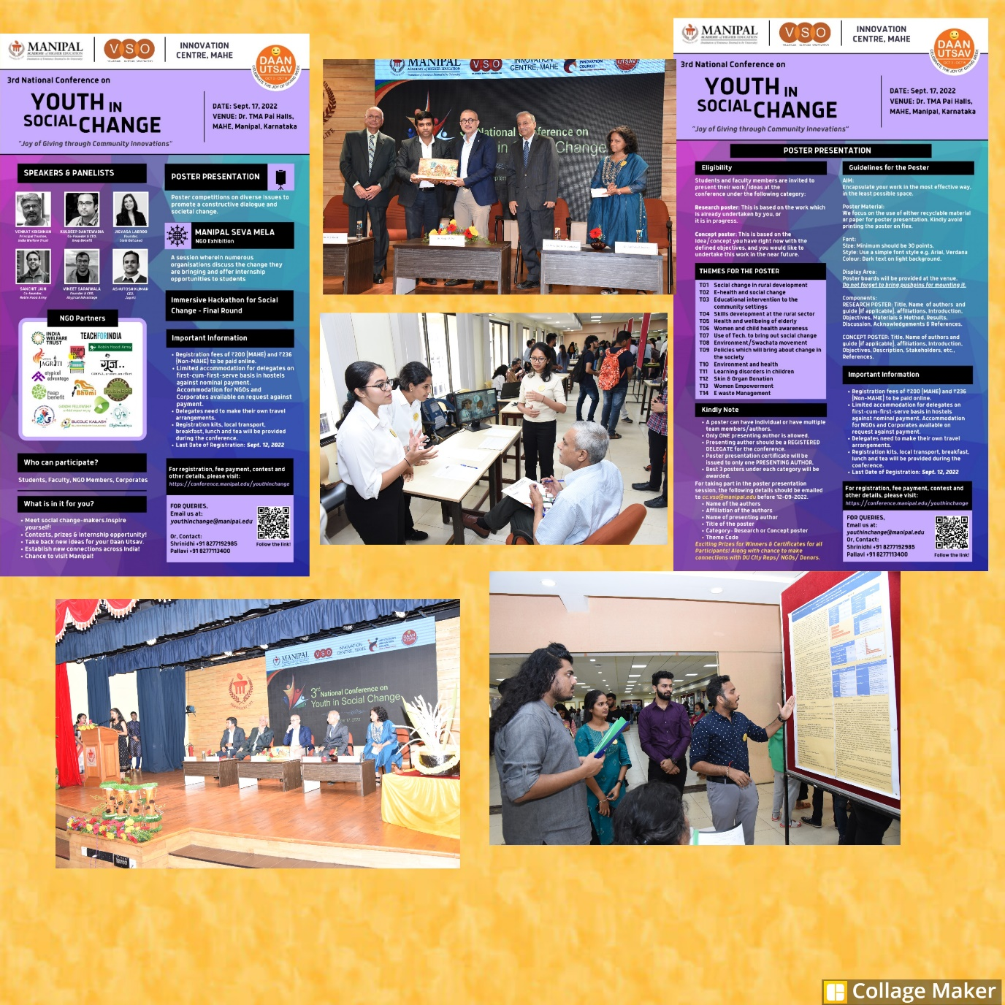
- Immersive Hackathon on Social Change (Exposure and Field Visit for Problem Identification)
The Innovation Centre, MAHE and Volunteer Services Organization (VSO), MAHE have jointly organized a unique immersive hackathon for solving social problems. This immersive hackathon has provided a platform to get connected with several immersive areas of VSO to identify the problem and provide the solution. The Hackathon started on 27th August 2022 with the orientation about VSO areas and procedure of hackathon. Further to that student participants have gone to immersive areas three consecutive Sundays and identified certain problem statements. As a part of hackathon, students submitted their problem statements individually and based on common problem areas teams have formed to participate in evaluations. Students prepared ppt/video/poster to present their ideas and solutions to solve the specific problems during National Conference on Youth in Social Change on 17th September 2022.
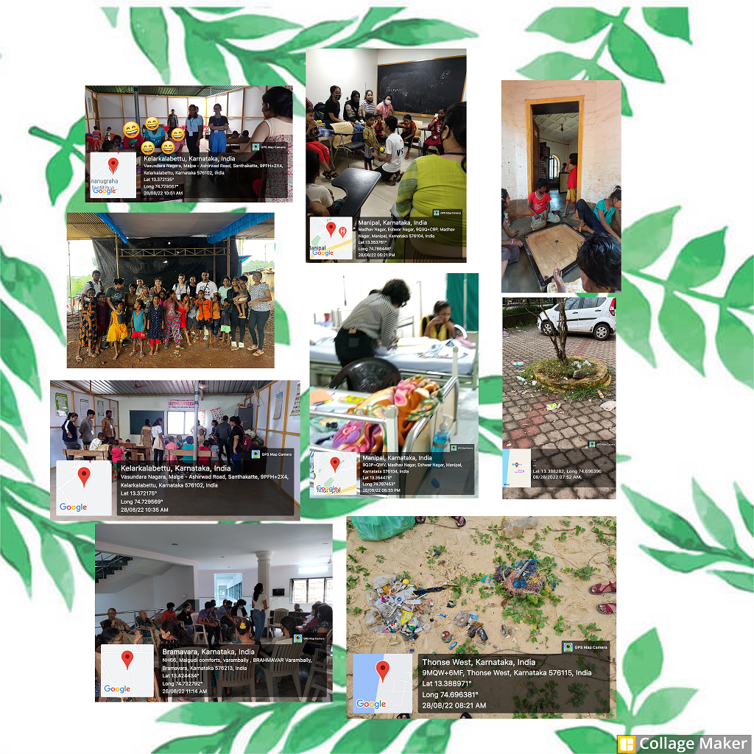
- Workshop on "R.E.INV.ENT Ecosystem” By Prof. Ravi B., IIT Bombay.
Innovation Centre - MAHE has organized a workshop on “R.E.INV.ENT Ecosystem” along with Manipal Universal Technology Business Incubator (MUTBI), MGoK-BioIncubator, Manipal College of Health Professions (MCHP), and Corporate Relations - MAHE for selected MAHE faculty for connecting Research, Education, Innovation and Entrepreneurship.
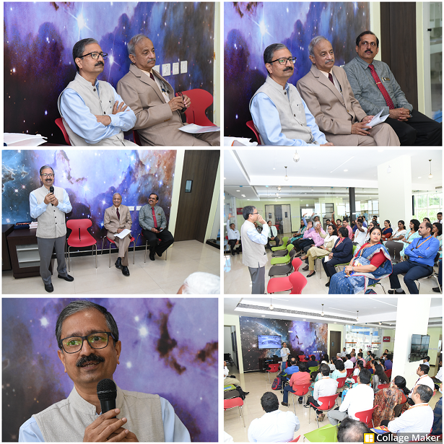
- AICS Prototype Challenger for Senior School Students: Theme-Innovate to Care
Madhava Kripa School. Manipal in collaboration with Innovation centre, MAHE hosted a Prototype Challenge contest for the students of Grade 11 and 12 belonging to the Association of ICSE and CBSE Schools, Udupi & D.K districts on 5 Nov 2022. The theme for the contest was Innovate to Care – 1. Care for the Elderly and 2. Care for your Teachers/Non-teaching staff/fellow students @school.
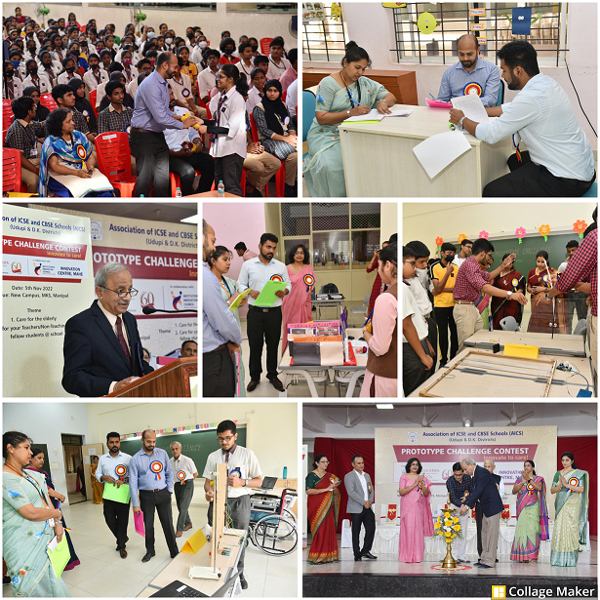
- Incandescent – The Ideation Fair
Incandescent – The innovation club of Manipal — conducted the Annual Ideation Fair on 7th November 2022. This event consists of multiple competitions like Medicina Genio, Double take, fiction concoction, and the Ideation competition to challenge some of the brightest minds on The Health Sciences campus.
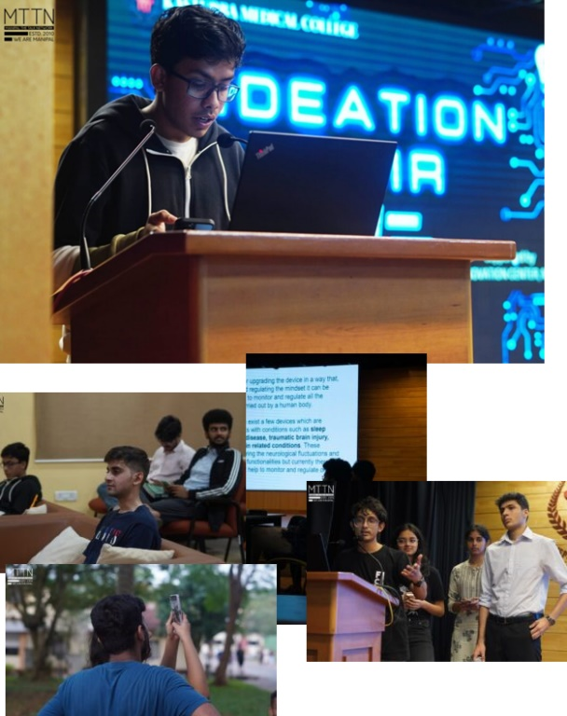
- IGNITE 1.0 Conference, MARENA, Mangalore
The IGNITE Conference, meticulously planned, and executed by the Innovation Centre and MAHESRF MCODS Mangalore, took place at MARENA in Mangalore on January 21st, 2023. The event provided a unique platform for entrepreneurs, innovators, and researchers to converge, exchange ideas, and network with like-minded individuals.
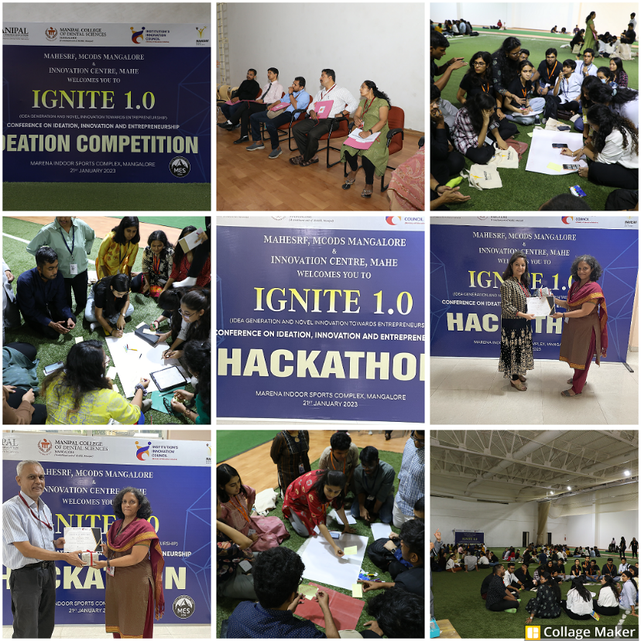
- Field/Exposure Visit by Students of BA in Culinary Arts, Welcomgroup Graduate School of Hotel Administration, Manipal
1st-year B.A. (Culinary Arts) students have visited the Innovation Center, Incubation Centres at MAHE Campus as part of the academic. The objective of the visit was to get exposure to an organization's IT setup and security requirements and explore innovation possibilities. As future decision-makers in the hospitality/culinary industry, our students need to know the importance of IT requirements.
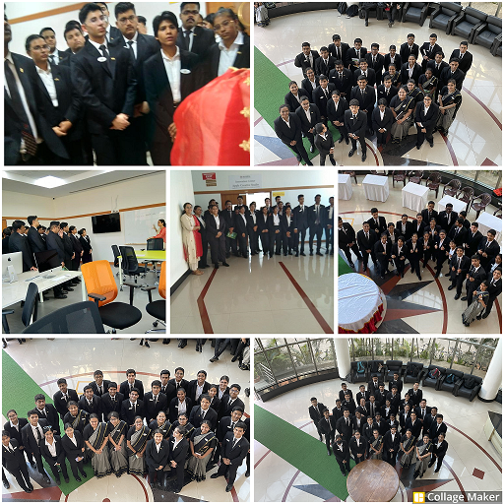
- FinTech Opportunities for Student Start-ups :
The Innovation Centre, MAHE organized a seminar titled "FinTech Opportunities for Student Start-ups" on August 1st, 2023, aiming to educate aspiring student entrepreneurs on leveraging technology effectively. With over 25 participants, the event provided insights into the current state of FinTech and its potential for student entrepreneurs. Prashanth Mane, an experienced professional from FIS, highlighted the company's collaboration with young entrepreneurs and its commitment to innovation. Attendees learned about FIS Global's resources and mentorship, empowering them to integrate FinTech seamlessly into their ventures. Overall, the seminar inspired students to explore FinTech opportunities and emphasized FIS Global's role as a reliable partner in their entrepreneurial journey.
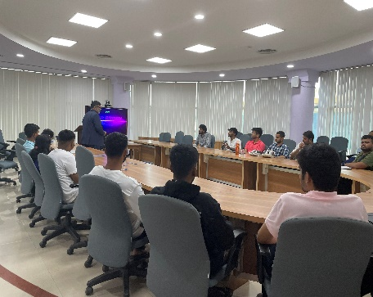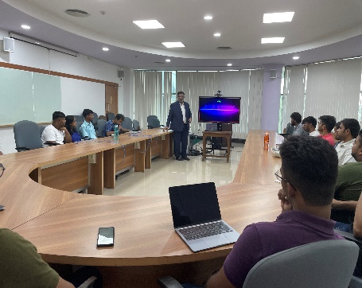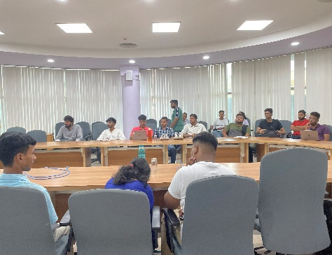
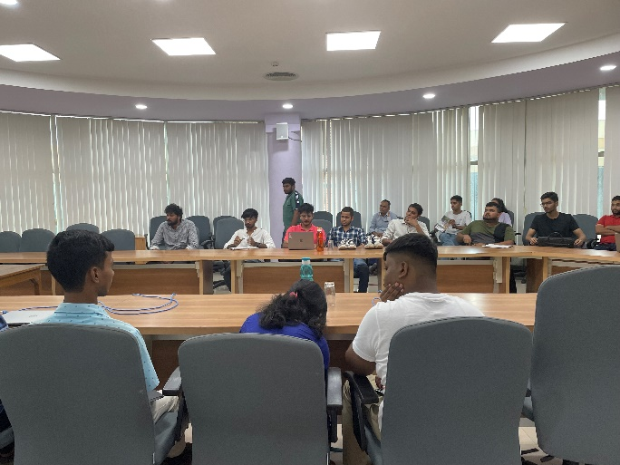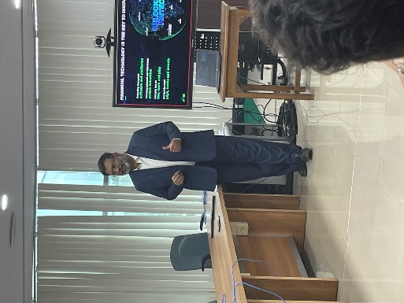
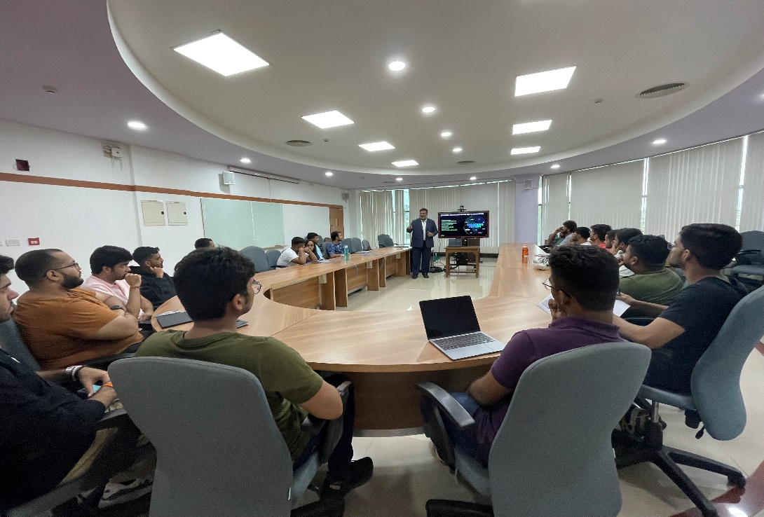
- AICS Prototype Challenger for School Students:
Innovation Centre, MAHE in collaboration with Madhava Kripa School, Manipal organized a series of online sessions prior to the AICS Prototype Challenge 2023. These sessions aimed to prepare participants from 12 AICS schools in Udupi and Dakshina Kannada districts. The sessions, facilitated via Google Meet, commenced with an orientation program on August 22nd, 2023, led by Dr. Sucheta V Kolekar, elucidating the significance of the challenge, its theme - Sustainable Development Goals, and adopting design thinking for problem-solving. Subsequent sessions on September 25th and October 26th, 2023, delved into ideation, prototyping, and business planning, featuring speakers Dr. Ravikiran Ongole and Sanjana Karkera, respectively. Dr. Mohammed Zuber, Chief Innovation Officer of the Innovation Cell at MIT, MAHE, provided additional insights, emphasizing market research, idea validation, and lean canvas approaches. These sessions equipped participants with crucial skills and strategies to navigate the AICS Prototype Challenge effectively.
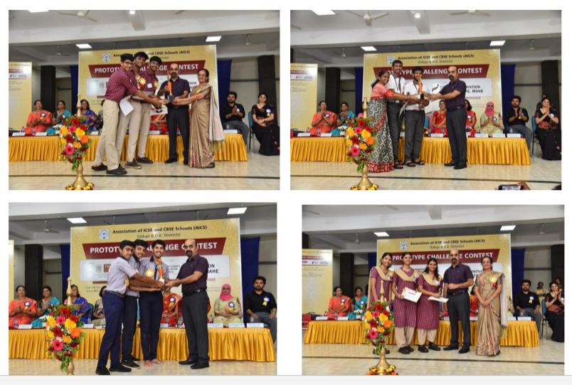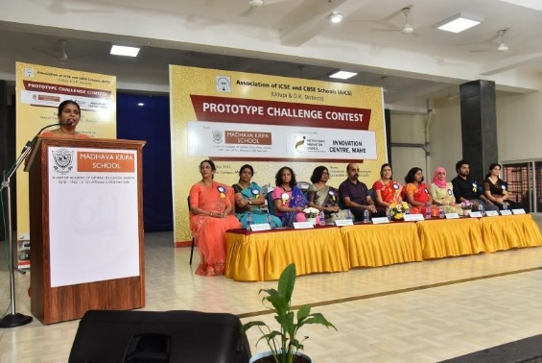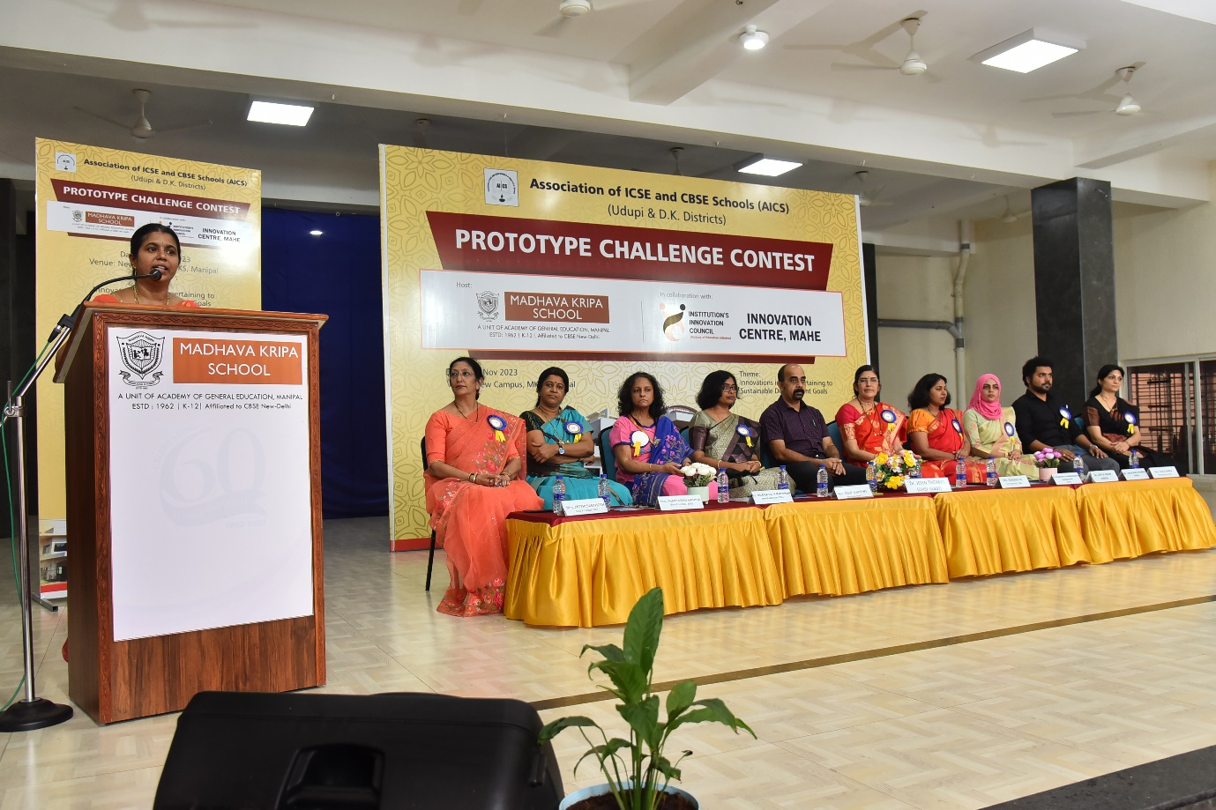

- AppLab HackXhibit '23:
The AppLab HackXhibit '23, organized by the Apple Developers' group in collaboration with MAHE's Innovation Centre, aimed to promote innovation and entrepreneurship, aligning with W20's focus on gender equity within the G20 discussions. With cash prizes totaling 1.5 lakhs and special awards for women-led teams and apps addressing W20 problem areas, the event attracted over 70 teams and 180 participants. Held from 17th February to 19th March 2023, the 36-hour hybrid hackathon saw participants creating solutions under themes like W20 in G20, Innovation, and Upliftment. Despite challenges, the event was a triumph, fostering collaboration, innovation, and skill development among students across disciplines and backgrounds, underscoring MAHE's commitment to nurturing an innovation-driven ecosystem.
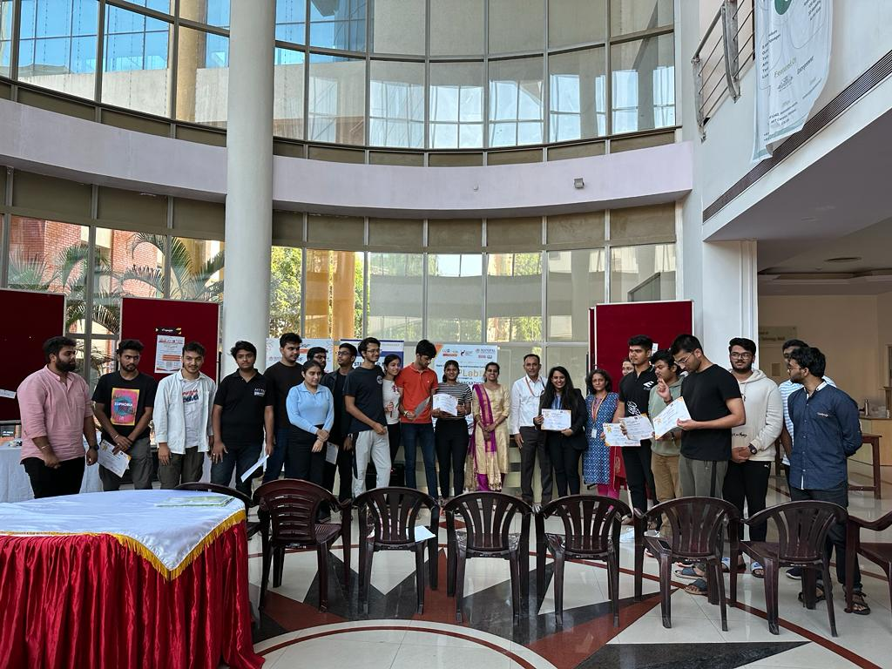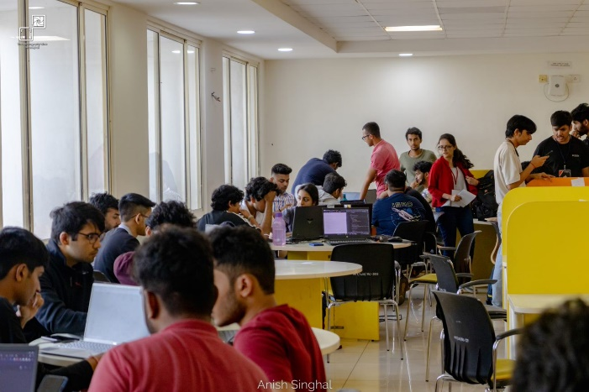
- Design Dentaverse Manipal 1.0 Hackathon 2023:
The Design Dentaverse Manipal 1.0 Hackathon 2023, held at Manipal School of Architecture and Planning (MSAP), MAHE, concluded with resounding success. Organized by a collaboration between MCODS Manipal, MSAP Manipal, and the Innovation Centre, the event saw enthusiastic participation from students across disciplines. Faculty members, including Dr. Shruti Acharya, Dr. Komal Smriti, Dr. Mohammed Zuber, Dr. Sucheta Kolekar, and others, played pivotal roles in orchestrating the event. Student volunteers, under the coordination of Lavanya Prakash, Tanya Aggarwal, and Paranjay Bhawsinghka, contributed tirelessly to its execution. The hackathon featured mentoring sessions, talks on entrepreneurship, and a rigorous judging process, culminating in the recognition of the top five innovative ideas. With plans for expansion in subsequent editions, this event promises to catalyze further innovation and collaboration at MAHE.
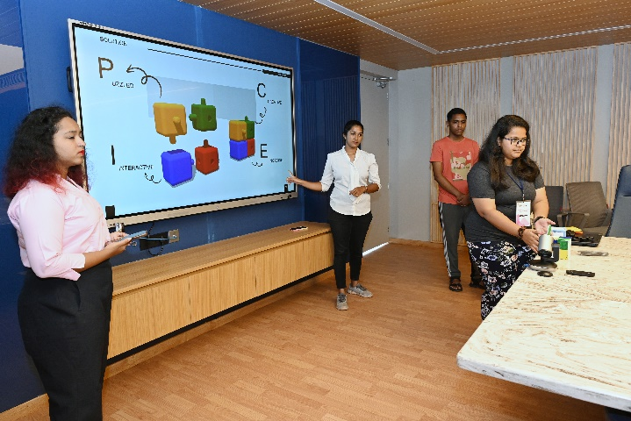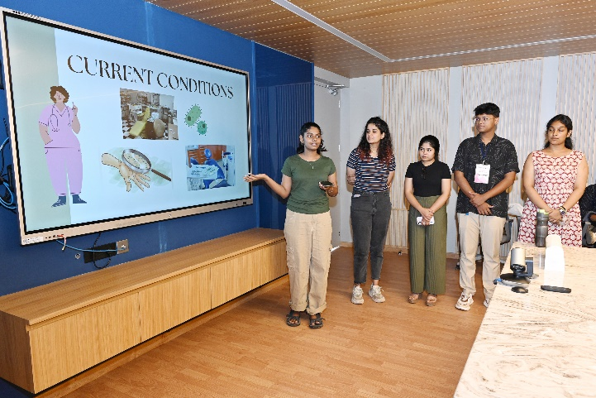
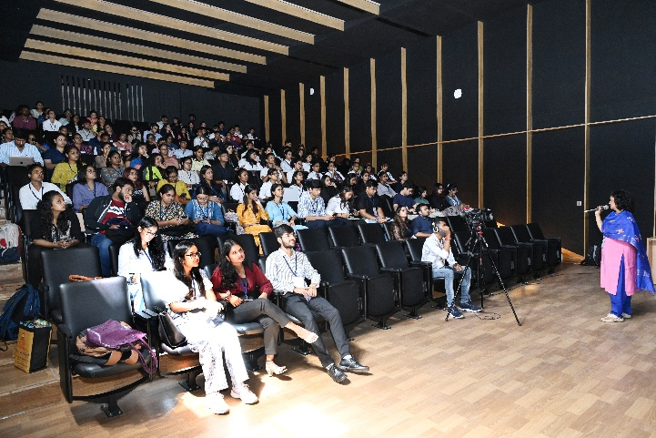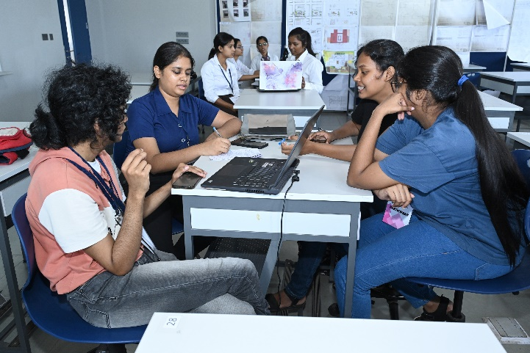
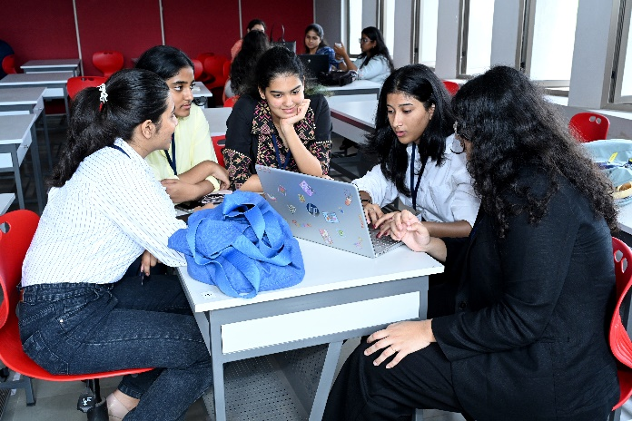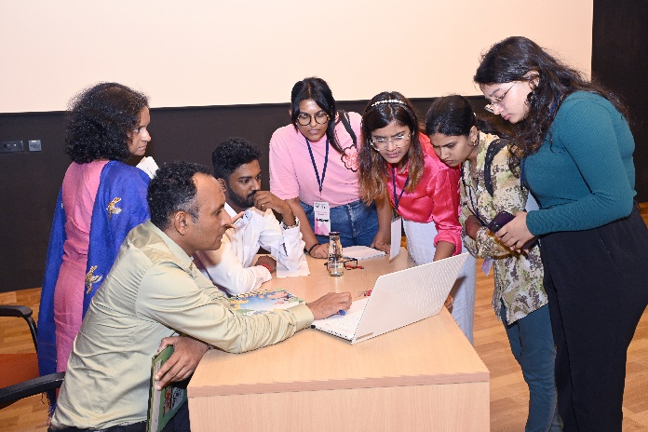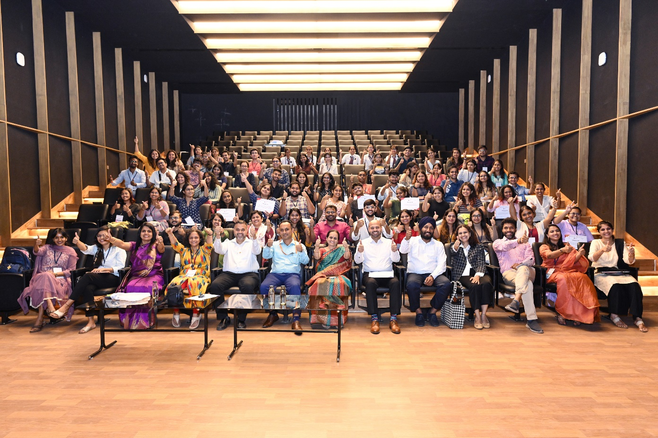

- Illuminate Entrepreneurship Workshop :
The Illuminate Entrepreneurship Workshop, held on 23/11/2023, jointly organized by E-Cell IIT Bombay and E-Cell MIT, aimed to empower aspiring entrepreneurs through practical insights into entrepreneurship, business modeling, marketing, and finance. Featuring keynote speaker Mr. Akhil Tejaa, a seasoned entrepreneur, the event commenced with an inspiring address, followed by hands-on sessions where participants formed teams to develop startup ideas using business modeling canvases. The highlight was a dynamic two-minute pitch session, showcasing innovative ideas and fostering constructive feedback. Overall, the workshop successfully blended expert insights with hands-on learning, setting a positive tone for future entrepreneurial endeavors within the college community and contributing to its innovation ecosystem.
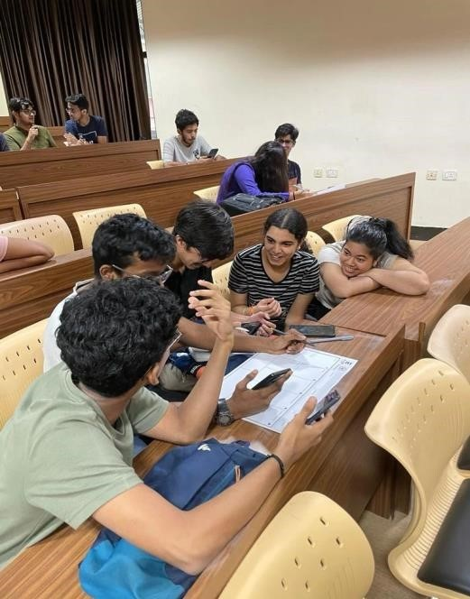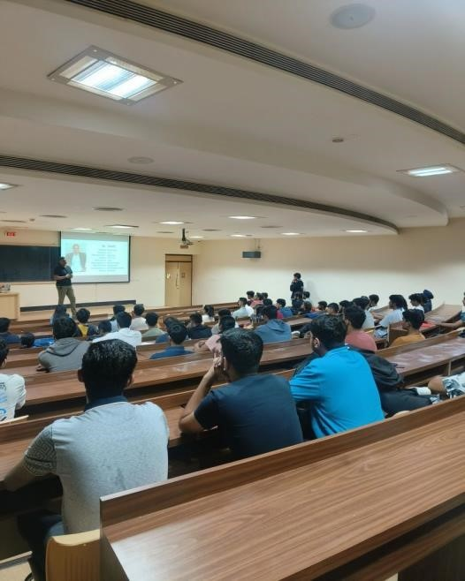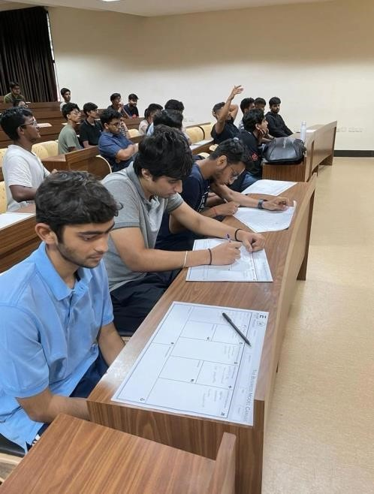

- Lifeathon 2024: Bridging Healthcare and Technology
Lifeathon 2024, a distinctive hackathon aimed at bridging the gap between healthcare professionals and technology solution providers to tackle contemporary healthcare challenges, was held on June 8th, 2024. This event was a collaboration` between the Innovation Centre, MAHE, MIT Manipal, and KMC Manipal. During the event, 30 teams, comprising both healthcare and technology experts, presented their proposed solutions to a panel of judges from clinical, industry, and intellectual property backgrounds. Five teams were awarded cash prize worth Rs. 1 Lakh each. By bringing together expertise from healthcare and technology, Lifeathon 2024 fostered innovative approaches and solutions, reinforcing the value of collaborative problem-solving in advancing healthcare.
